CSC-20021

Part 2: Single Page Application

Student Number: W4S22

Student Name: Alex Farrell

**Contents**

Animation 3

User Interactions 4

Snow Intensity 4

Soundtrack 4

Frameworks 5

JQuery 5

Math.JS 5

**Live version:**

Due to not being at Keele when this part of the coursework was completed, there is not a live version of this available to view.

# **Animation**

The animation (snow) element utilizes a HTML5 canvas that is set to the size of the window in which the website is being output (see figure 1 below). The snow particles are stored in a Stack. Each particle has an x coordinate, y coordinate, radius, and density. These attributes are randomly generated to reflect the randomness of snowflakes in real life.

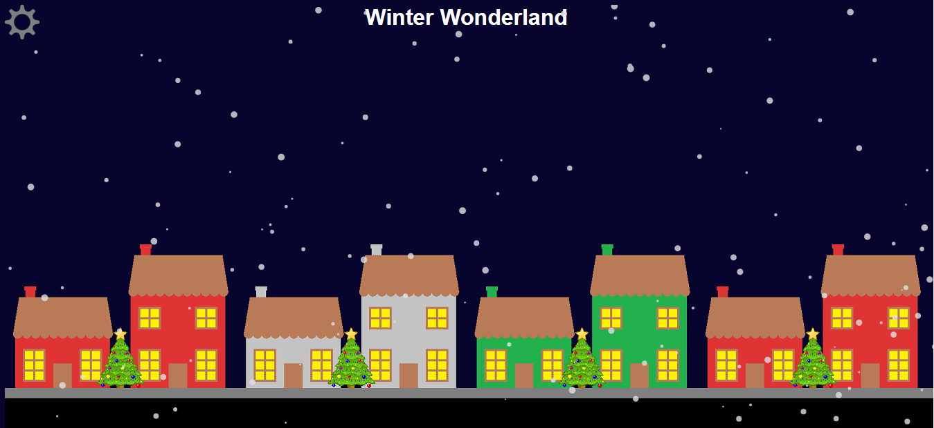

Figure 1: Page highlighting the animation

Each time the canvas is redrawn, each snow particle is redrawn in its new position. When a snowflake reaches the edge of the screen, it is returned to the top of the screen. Depending on where the snowflake exits (sides or bottom), it would either re-enter the screen from the side or the top. The animation is looped using the *setInterval* function which requires the name of the function which draws to the canvas, and the number of milliseconds between each call to draw.

# **User Interactions**

## **Snow Intensity**

This setting allows the user to change the number of snowflakes that are drawn to the screen. There are 3 different settings (see figures 2, 3, & 4 below).

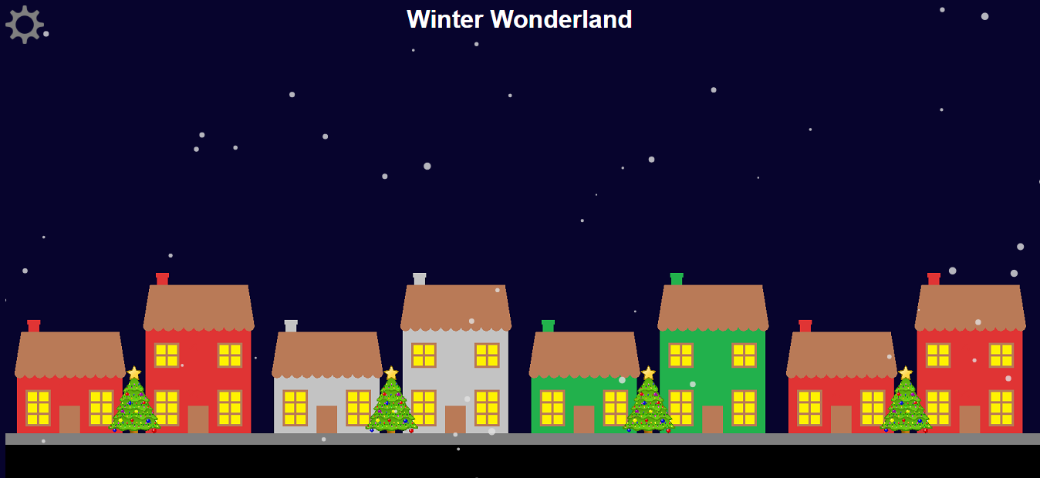

Figure 2: Light snow

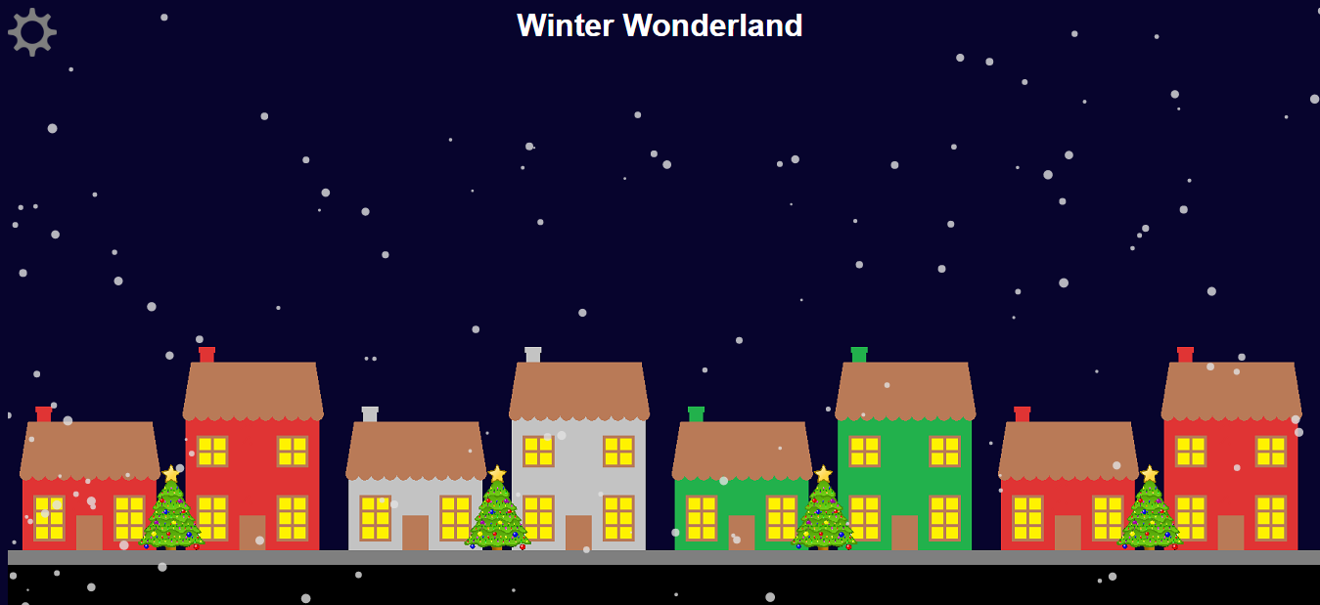

Figure 3: Medium snow

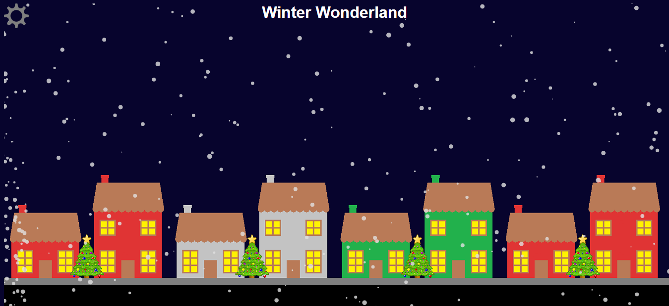

Figure 4: Heavy snow

This setting is chosen by a dropdown menu which sends the value to the *snowflake* function, changing the number of snowflakes that are rendered to the screen (see figure 5 below).

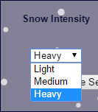

Figure 5: Change intensity of the snow

## **Soundtrack**

There is a backing soundtrack that plays when the page is loaded. There are then 2 other songs which the user can choose to play. This setting is chosen by a dropdown menu which send the song filename to the *soundtrack* function, changing the source of the audio element, changing the song which is plays in the background (see figure 6 below).

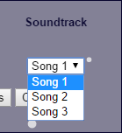

Figure 6: Change soundtrack

# **Frameworks**

## **JQuery**

The jQuery framework has been used to handle the animation of the settings box which fades in the settings icon is pressed, and fades out when the user presses the ‘update settings’ or ‘cancel’ button. JQuery has built in functions which automatically handle the event rather than having to program it yourself. This animation is possible using CSS, however from experience, I have found that it is much easier doing it this way.

## **Math.JS**

The Math.JS library has been used to support the snow animation on the screen. The *Math.random* function has been sued to generate random numbers which help determine the coordinates, radius, and density of each of the snowflake particles. *Math.PI* has been used to draw the snowflake particles to the screen.